

Solution Architecture

Date | 23 JUNE 2026
Team ID | SWTID-2026-7169
Project Name | OptiCrop: Smart Agricultural Production Optimization Engine
Maximum Marks | 5 Marks

Solution Architecture Diagram:
Provide a high-level visual representation of your solution's architecture. Use the structural layout below as a template to map out your Presentation Layer, Application Layer, and Data Layer. Fill in the specific technologies and components for your project directly into the boxes to create your architectural diagram.

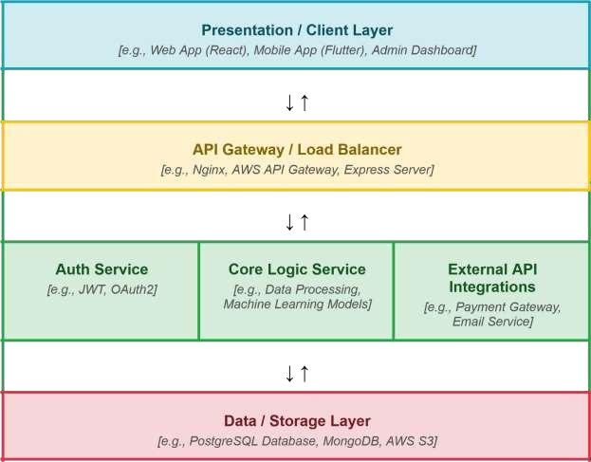




Component Description Table

Component Name | Description / Role in Architecture | Technologies Used
Presentation Layer | Renders the Home, About, and Find Your Crop pages; collects user input (N, P, K, temperature, humidity, pH, rainfall) via a form and displays the  predicted crop. | HTML, CSS, Bootstrap, Jinja2 (Flask templating)
API Gateway | Not used in current architecture — Flask's built-in routing handles all requests directly (Home, About,  FindYourCrop, Predict routes) | Flask routing (@app.route)

Microservices | Single Flask service that receives form input, passes it to the trained ML model via model.predict(), and returns the  crop recommendation to the UI | Python, Flask, Scikit-learn, Pickle
Database | Stores the training dataset used to build the model and the serialized model file used for inference; no live  database/transactional storage is used | CSV file (Crop_recommendation.csv), Pickle (model.pkl)

